Name: Kushang Darbar(18EC017)

PROGRAM 1

AIM: Flash/Toggle/on off single led

CODE:

#define led 13

void setup() {

// put your setup code here, to run once:

pinMode(led,OUTPUT);

}

void loop() {

// put your main code here, to run repeatedly:

digitalWrite(led,HIGH);

delay(1000);

digitalWrite(led,LOW);

delay(1000);

}

RESULT:

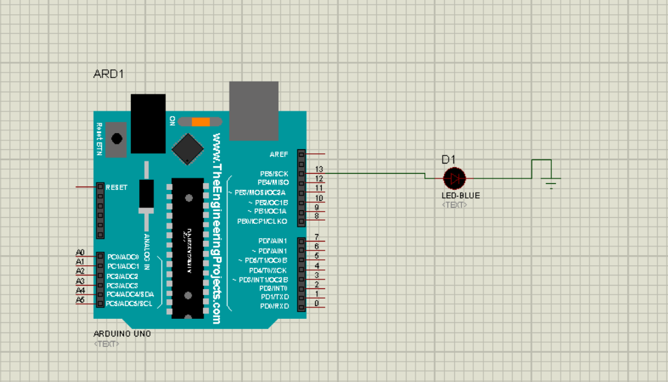

PROGRAM 2

AIM: Flash/Toggle/on off eight leds

CODE:

void setup() {

// put your setup code here, to run once:

for(int i=6;i<=13;i++)

{

pinMode(i,OUTPUT);

}

}

void loop() {

// put your main code here, to run repeatedly:

for(int i=6;i<=13;i++)

{

digitalWrite(i,HIGH);

}

delay(1000);

for(int j=6;j<=13;j++)

{

digitalWrite(j,LOW);

}

delay(1000);

}

RESULT:

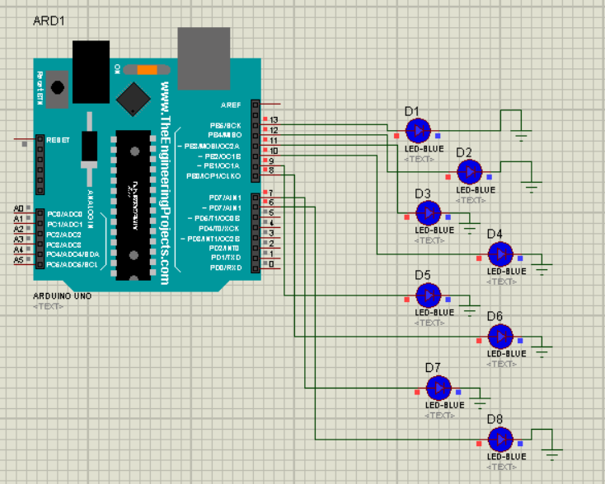

PROGRAM 5

AIM: Interface 8 leds. Generate left series patterns

CODE:

void setup() {

// put your setup code here, to run once:

for(int i=6;i<=13;i++)

{

pinMode(i,OUTPUT);

}

}

void loop() {

// put your main code here, to run repeatedly:

for(int i=6;i<=13;i++)

{

digitalWrite(i,HIGH);

delay(1000);

}

for(int j=13;j>=6;j--)

{

digitalWrite(j,LOW);

delay(1000);

}

}

RESULT:

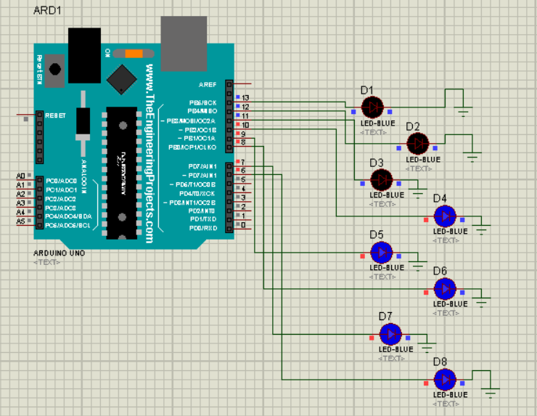

PROGRAM 3

AIM: Interface 8 leds. Out of 4 led on and 4 led off.

CODE:

void setup() {

// put your setup code here, to run once:

for(int i=6;i<=13;i++)

{

pinMode(i,OUTPUT);

}

}

void loop() {

// put your main code here, to run repeatedly:

for(int i=6;i<=9;i++)

{

digitalWrite(i,HIGH);

}

delay(1000);

/*for(int j=6;j<=13;j++)

{

digitalWrite(j,LOW);

}

delay(1000);*/

}

RESULT:

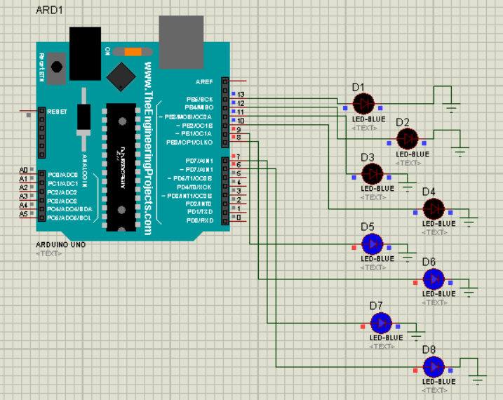

PROGRAM 4

AIM: Alternate on off 8 leds

CODE:

void setup() {

// put your setup code here, to run once:

for(int i=6;i<=13;i++)

{

pinMode(i,OUTPUT);

}

}

void loop() {

// put your main code here, to run repeatedly:

for(int i=6;i<=13;i++)

{

digitalWrite(i,HIGH);

delay(1000);

digitalWrite(i,LOW);

}

RESULT:

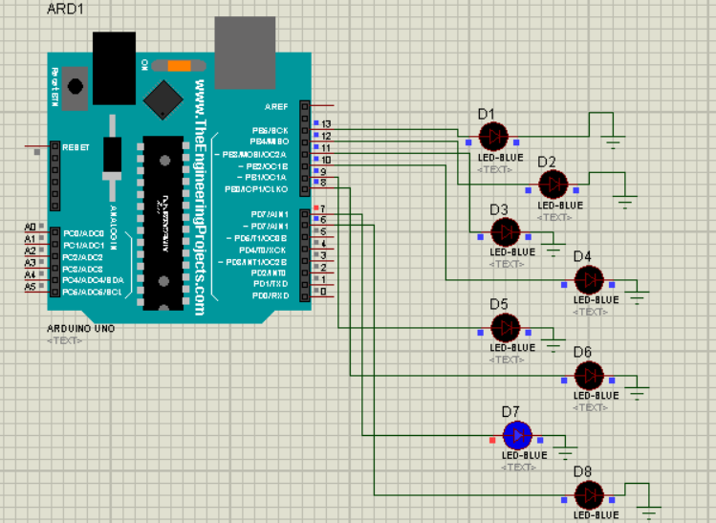

PROGRAM 6

AIM: Interface 8 leds. Generate right series patterns

CODE:

void setup() {

// put your setup code here, to run once:

for(int i=6;i<=13;i++)

{

pinMode(i,OUTPUT);

}

}

void loop() {

// put your main code here, to run repeatedly:

for(int j=13;j>=6;j--)

{

digitalWrite(j,HIGH);

delay(1000);

}

for(int i=6;i<=13;i++)

{

digitalWrite(i,LOW);

delay(1000);

}

}

RESULT:

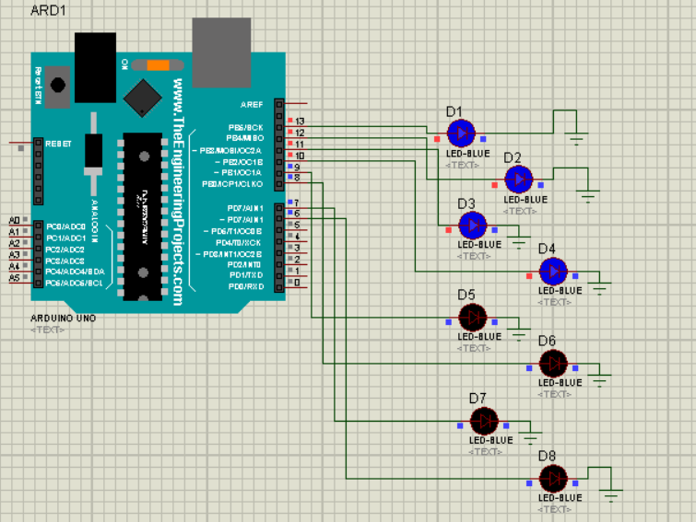

PROGRAM 8

AIM: Combine all above in single program

CODE:

#define led 13

void setup() {

// put your setup code here, to run once:

pinMode(led,OUTPUT);

for(int i=6;i<=13;i++)

{

pinMode(i,OUTPUT);

}

}

void loop() {

// put your main code here, to run repeatedly:

digitalWrite(led,HIGH);

delay(1000);

digitalWrite(led,LOW);

delay(1000);

for(int i=6;i<=13;i++)

{

digitalWrite(i,HIGH);

}

delay(1000);

for(int j=6;j<=13;j++)

{

digitalWrite(j,LOW);

}

delay(1000);

for(int i=6;i<=9;i++)

{

digitalWrite(i,HIGH);

}

delay(1000);

for(int i=6;i<=13;i++)

{

digitalWrite(i,HIGH);

delay(1000);

digitalWrite(i,LOW);

}

for(int i=6;i<=13;i++)

{

digitalWrite(i,HIGH);

delay(1000);

}

for(int j=13;j>=6;j--)

{

digitalWrite(j,LOW);

delay(1000);

}

for(int j=13;j>=6;j--)

{

digitalWrite(j,HIGH);

delay(1000);

}

for(int i=6;i<=13;i++)

{

digitalWrite(i,LOW);

delay(1000);

}

}

RESULT:

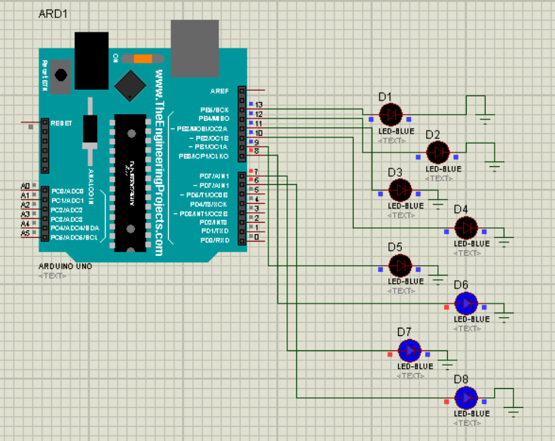

PROGRAM 7

AIM: Interface 8 leds. Generate right series patterns

CODE:

void setup() {

// put your setup code here, to run once:

for(int i=6;i<=13;i++)

{

pinMode(i,OUTPUT);

}

}

void loop() {

// put your main code here, to run repeatedly:

for(int i=6;i<=13;i++)

{

digitalWrite(i,HIGH);

delay(1000);

}

for(int j=13;j>=6;j--)

{

digitalWrite(j,LOW);

delay(1000);

}

for(int j=13;j>=6;j--)

{

digitalWrite(j,HIGH);

delay(1000);

}

for(int i=6;i<=13;i++)

{

digitalWrite(i,LOW);

delay(1000);

}

}

RESULT:

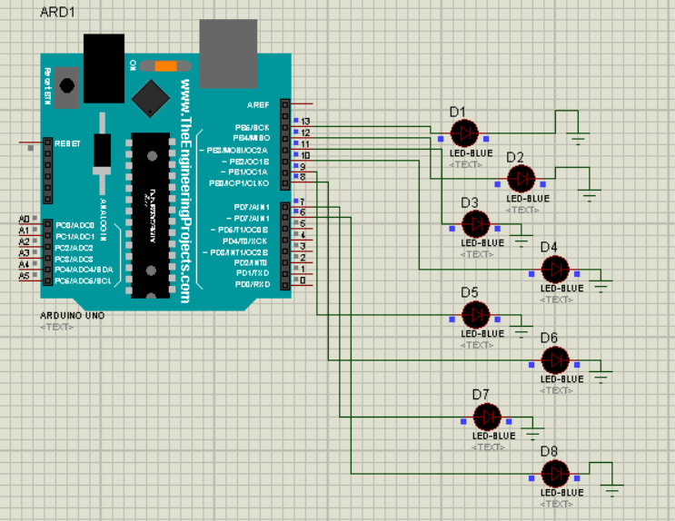

PROGRAM 9

AIM: Display 00 to FF on led

CODE:

void setup() {

for(int i=0;i<8;i++)

{

pinMode(i,OUTPUT);

}

}

void loop() {

for(int a=0;a<2;a++)

{

digitalWrite(7,a);

for(int b=0;b<2;b++)

{

digitalWrite(6,b);

for(int c=0;c<2;c++)

{

digitalWrite(5,c);

for(int d=0;d<2;d++)

{

digitalWrite(4,d);

for(int e=0;e<2;e++)

{

digitalWrite(3,e);

for(int f=0;f<2;f++)

{

digitalWrite(2,f);

for(int g=0;g<2;g++)

{

digitalWrite(1,g);

for(int h=0;h<2;h++)

{

digitalWrite(0,h);

delay(500);

}

}

}

}

}

}

}

}

}

RESULT:

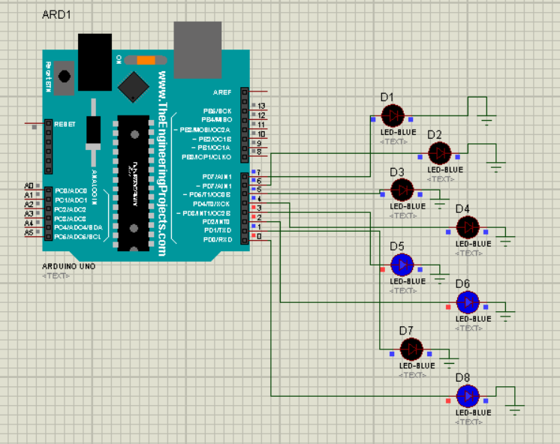

PROGRAM 10

AIM: Sound the buzzer every one second

CODE:

#define BUZZER 13

void setup() {

// put your setup code here, to run once:

pinMode(BUZZER,OUTPUT);

}

void loop() {

// put your main code here, to run repeatedly:

digitalWrite(BUZZER,HIGH);

delay(1000);

digitalWrite(BUZZER,LOW);

delay(1000);

}

RESULT:

PROGRAM 11

AIM: Display 0 to 9 on segment

CODE:

void setup() {

// put your setup code here, to run once:

for(int i=0;i<=7;i++)

{

pinMode(i,OUTPUT);

}

}

int seg_code[10]={0xFC,0x60,0xDA,0xF2,0x66,0xB6,0xBF,0xE0,0xFF,0xF7};

void loop() {

// put your main code here, to run repeatedly:

for(int i=0;i<=7;i++)

{

PORTD=seg_code[i];

digitalWrite(PORTD,HIGH);

delay(1000);

digitalWrite(PORTD,LOW);

delay(1000);

}

}

RESULT:

